RESUME
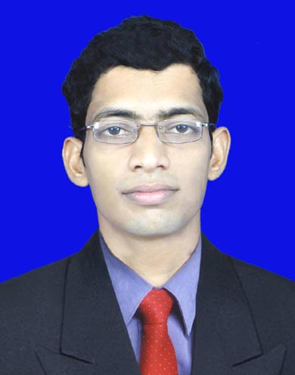
MIRZA SABRAT BAIG

E-mail: mirzasabratbaig99@gmail.com
Mobile919853112114
- Date of Birth : 10th February 1987
- Gender : Male
- Father name : Late-Mirza Karim Baig
- Nationality : Indian
- Religion : Muslim
- Marital Status : Single
- Languages : Odiya ,Hindi & English
- Permanent address : At-Balisahi,Po-Balikuda
- Dist- Jagatsinghpur
Pin-754108

OBJECTIVE

To learn and function effectively in an organization and be able to deliver to the bottom-line.
To constantly upgrade my knowledge and skills and make a difference in whatever I do.
ACADEMIC QUALIFICATION
NAME OF DEGREE QUALIFICATION | NAME-OF SCHOOL/COLLEGE | Board/  University | YEAR OF PASSING | %AGE
MCA | Regional College of Management (A) | Autonomous | 6th sem.Cont.
Bsc.(Zoology) | Balikuda High School High School, Balikuda | Utkal University,  Odisha | 2009 | 51
+2 science | Balikuda High School High School, Balikuda | CHSE | 2005 | 47
10TH | Balikuda High School High School, Balikuda | BSE, Odisha | 2003 | 48

COMPUTER SKILLS

- C Language,C++, LanguageVisual, BasicHTML,MS Office & Hardware Networking.
- A sound knowledge in hardwiring

DECLARATION

I do herby declare that the particulars of information and facts stated here in above are true, correct and complete to the best of my knowledge and belief.

(Signature)
PLACE: BHUBANESWAR Mirza Sabrat Baig
DATE :

